 ARES – the new Automated Reserve System

Welcome to the new Course/Electronic Reserve System – ARES
You as a faculty will now be able to take a more active role in adding items to your reserve listing or if you still prefer, contact the Course Reserve Office and they will do it for you. We will still scan directly from books and/or journals for you and process the items required. Look over the following instructions – don’t hesitate to call us with questions and concerns.

1. Log in – using your GVSU user name and password
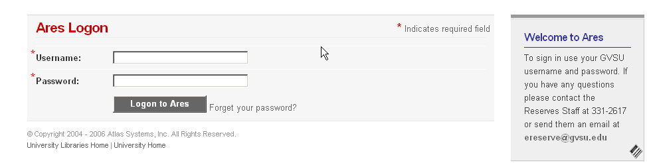

2. Choose from Instructor Tools: Create New Class

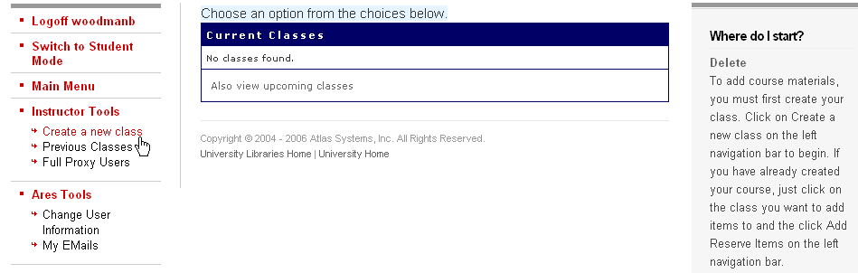

3. Fill in the Form for “Create a Class”

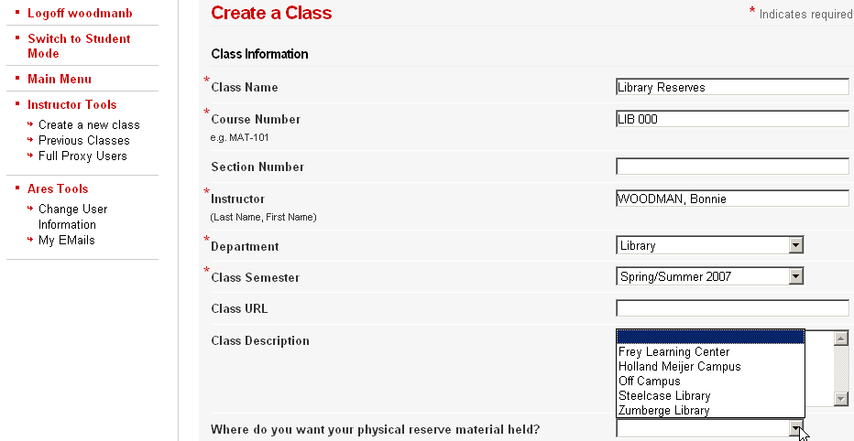
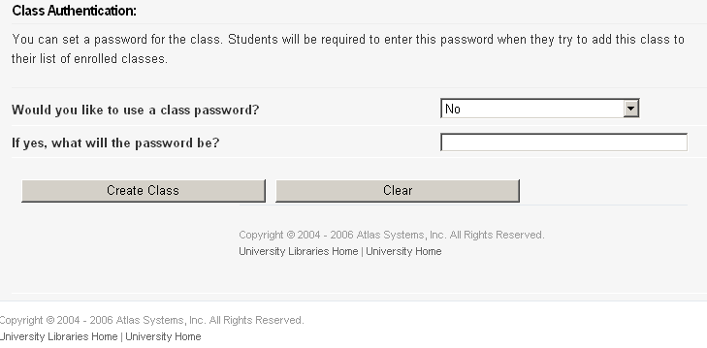

4. Click on “Create Class” button – the next will be:

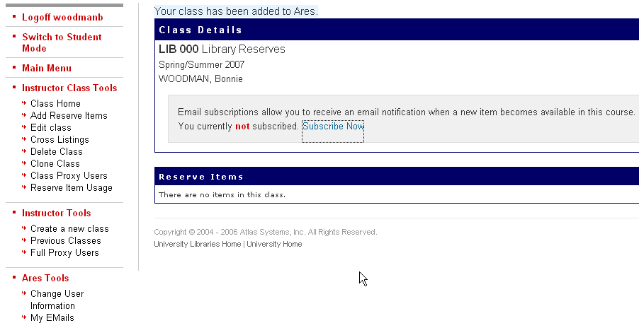

5. You may now start adding items to your listing. - Go to Instructor Class Tools on left side toolbar and click on * Add Reserve Items

At the next screen you will choose which type of item you wish to place on reserve
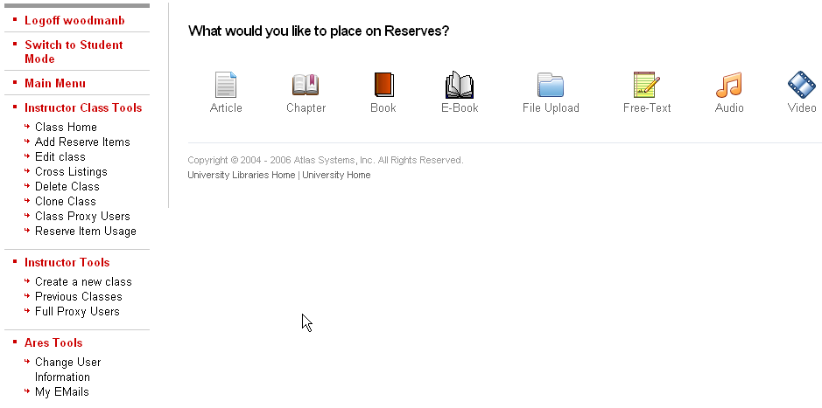

NOTE: ‘File Upload’ is for WORD documents, such as your syllabus, exams, etc.

6. at each item – there will be a form you will need to fill out as completely as possible – if you encounter any problems, notify the Course Reserve Dept at 1-2617

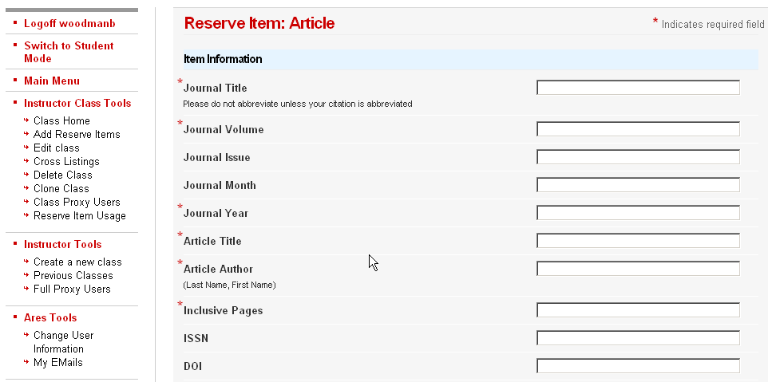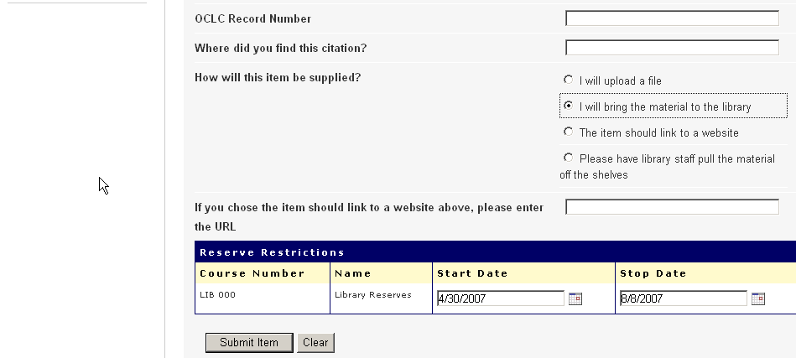

7. Be sure to indicate ‘How Will this Item be Supplied?” – then click on submit item

You will receive confirmation for the item ….

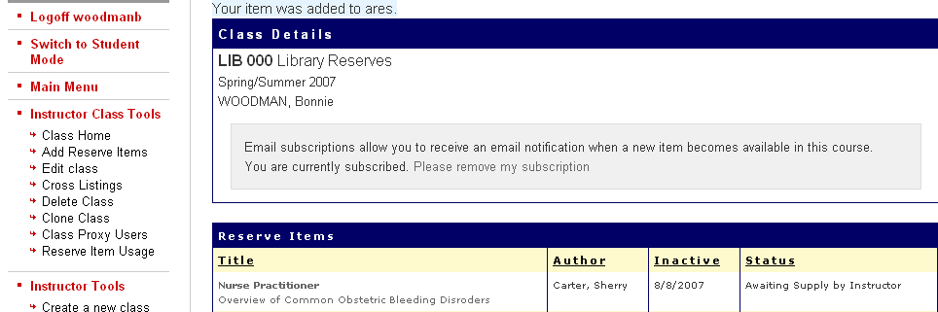

Form for book:

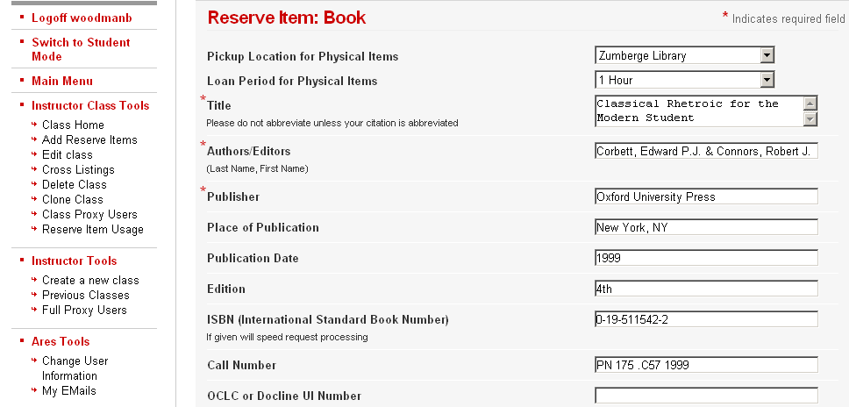
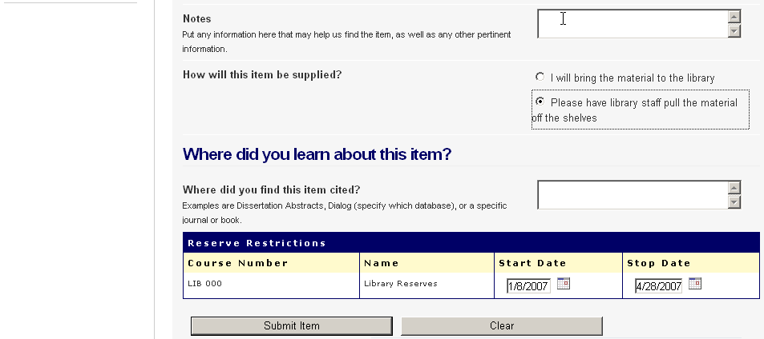

Form for book chapter:

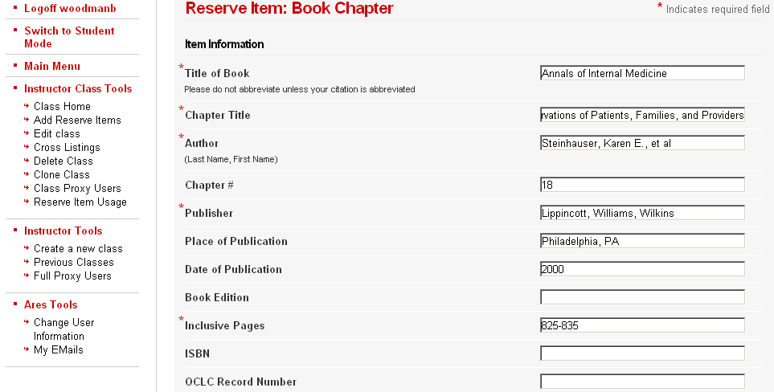
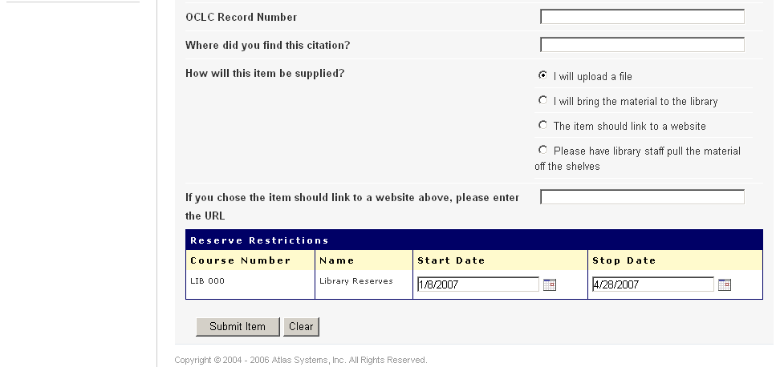

“I will upload file” was chosen, so at the next screen you need to locate the item, copy and paste it into the ‘choose a file to upload’ link

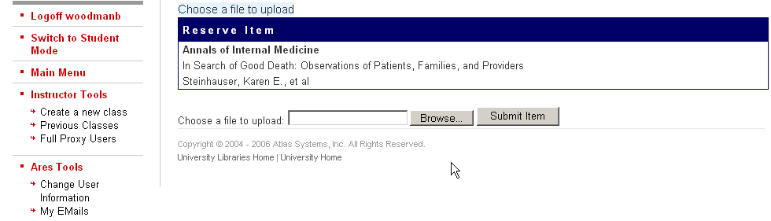

URL for item will appear, then hit ‘Submit Item’
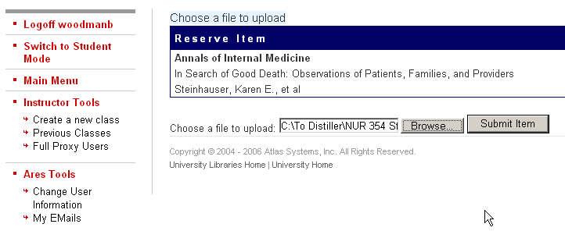

you will receive notice “Your file was successfully uploaded”
NOTE: STATUS on far right will show it’s available on Electronic Reserve
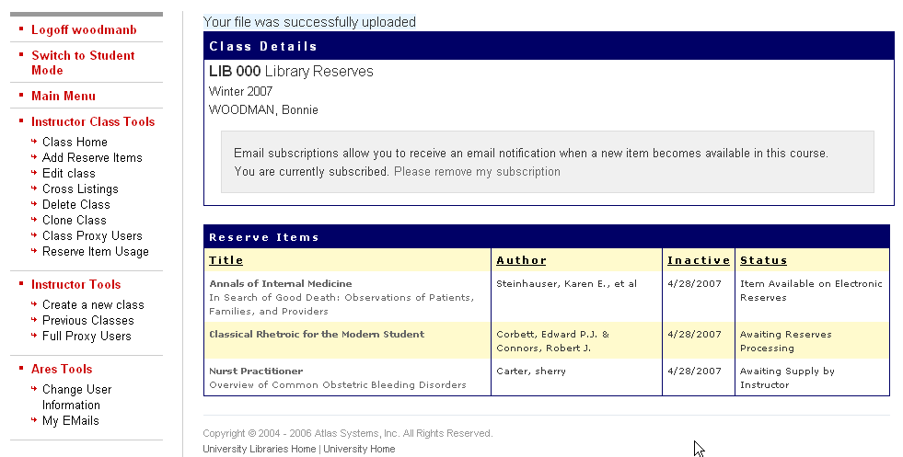

Click on the item title to view
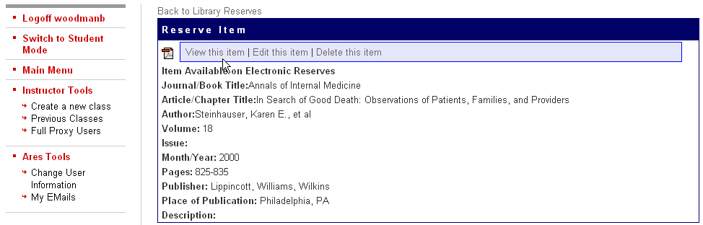

then click on “View this Item”

Your class list will look like this:

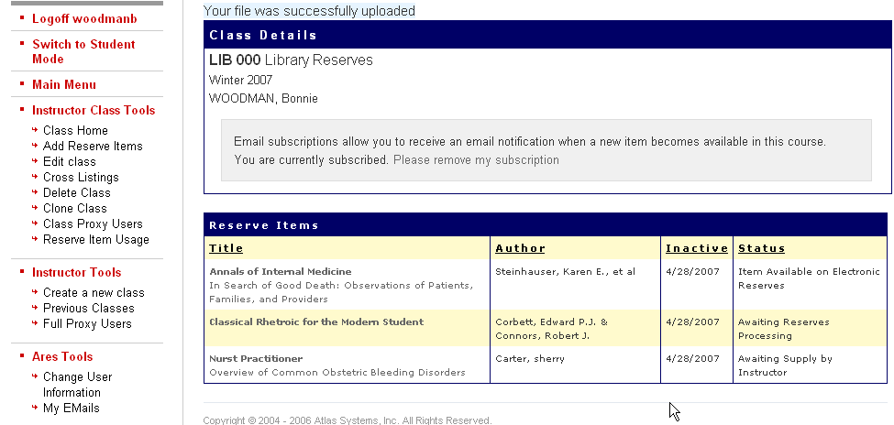

To add an E-Book to your listing: first find item in GVSU catalog and take down all information required.

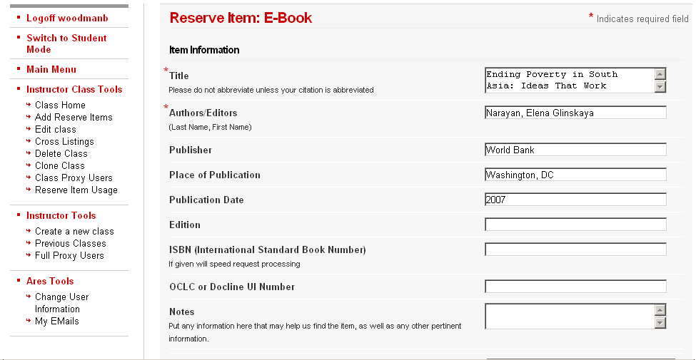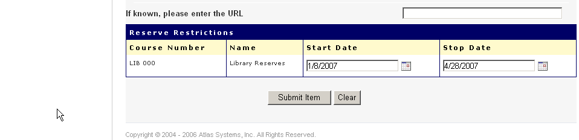

you will note that an e-book is ‘check for Proxy’ – our staff will link the item so students can view
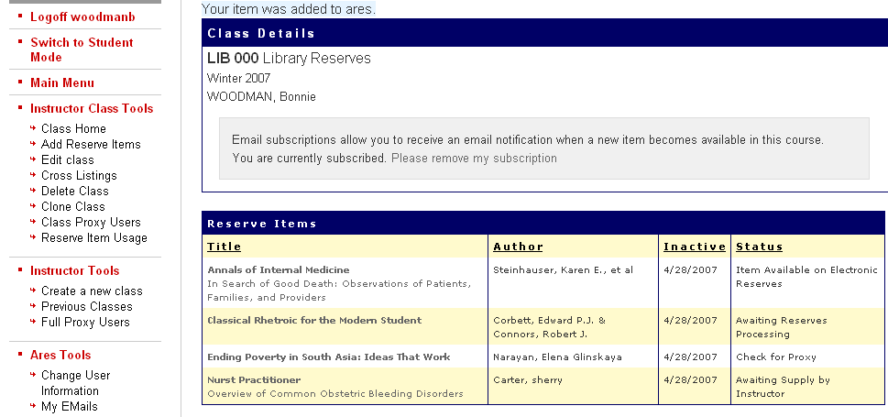

Once you listing is complete, you can change items, adding, deleting, cross listing to another class even look up Reserve item usage. You can create a new class and follow through the steps above.
If at any time you have questions or concerns, notify the Course Reserve Department at 1-2617

Be sure to logoff – when finished

STUDENTS:

Click on the Course Reserve icon on the library’s homepage
Will need to login also
Find the class they are registered for
Then click on item needed

CR staff will link, upload and do all final checks before students can view – item will be noted when available

Questions and Concerns??:
Bonnie Woodman
Course Reserve Coordinator
108 JHZ Library – Allendale Campus
Phone: (616) 331-2617
E:mail: woodmanb@gvsu.edu or
E:mail: ereserve@gvsu.edu

